The data for the case study originate from Purhonen et al. (2020):

Purhonen, J., Ovaskainen, O., Halme, P., Komonen, A., Huhtinen, S., Kotiranta, H., Læssøe, T. and Abrego, N. 2020. Morphological traits predict host-tree specialization in wood-inhabiting fungal communities. *Fungal Ecology* **46**, 100863. <https://doi.org/10.1016/j.funeco.2019.08.007>

**Brief description of the study design:** The study was carried out in central Finland. 192 logs in 12 study sites were surveyed for fungal fruiting bodies. All 12 study sites were semi-natural spruce dominated forests that varied relatively little in their age and management history. From each forest, 16 large (base diameter > 15 cm) naturally fallen logs were selected: four birch logs, four spruce logs, four pine logs and four aspen logs. The study thus consists of a total of 12 x 16 = 192 logs. These logs were thoroughly surveyed for fungal sexual fruiting bodies, yielding in total for 657 species. For these fungal species, information about their traits (fruit-body and spore morphology) and taxonomy were compiled.

**Environmental data are provided in the file environment.csv.** These data contain information about the 192 logs (column id) included in the study: their tree species (column tree), their volume in cubic meters (column volume), their decay stage classified as 2, 3 or 4 (column decay), the name of the forest site (column site), and an index characterizing how natural the forest is (column index; the higher, the more natural).

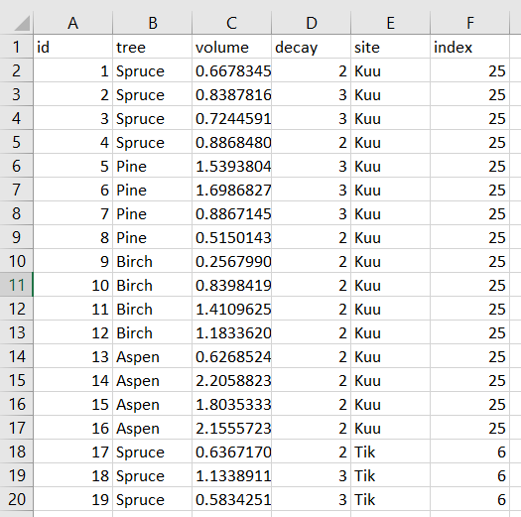

*Shown is the head of the file environment.csv.*

**Species occurrence data are provided in the file species.csv.** These data contain information about the presence-absences of the 657 species (the columns with species names) on the 192 logs (column id) included in the study.

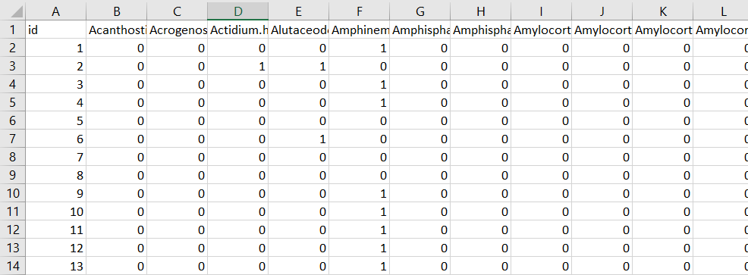

*Shown is the head of the file species.csv.*

**Species trait and taxonomical data are provided in the file traits.csv.** These data contain the following information about the presence-absences of the 657 species (column species) included in the study: fruit body type (column fb), thickness of spore cell wall (column wall), whether the spores have ornamentation (column orn), the shape of the spore (column shape; ratio of length to width), spore volume (column volume), and taxonomical classification (columns phylum, class, order, family, genus).

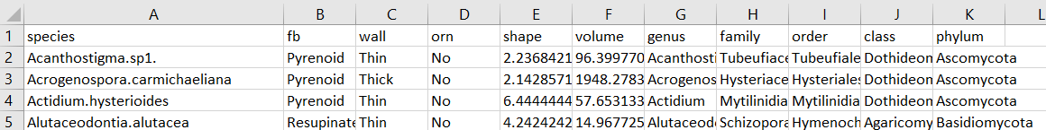

*Shown is the head of the file traits.csv.*

**HMSC PIPELINE CONSISTS OF THE FOLLOWING SCRIPTS:**

* S1_define_models.R
* S2_fit_models.R (you must define a model before running this one)
* S3_evaluate_convergence.R (you must run S2 before running this one)
* S4_compute_model_fit.R (you must run S2 before running this one)
* S5_show_model_fit.R (you must run S4 before running this one)
* S6_show_parameter_estimates.R (you must run S2 before running this one)
* S7_make_predictions.R (you must run S2 before running this one)